Circuit Breaker

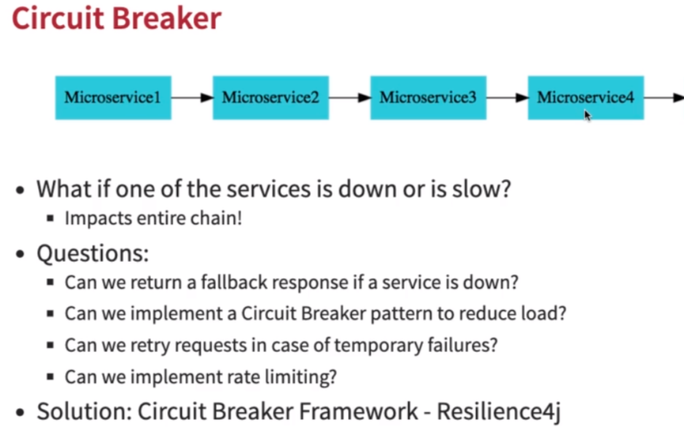
https://resilience4j.readme.io/docs/circuitbreaker

Different configurations of Resilience4j Library
You can choose between a count-based sliding window and a time-based sliding window. For example, we can configure a count-based circuit breaker to “open the circuit” if 70% of the last 25 calls failed. Similarly, we could tell a time-based circuit breaker to open the circuit if 80% of the calls in the last 30s failed.

To understand the circuit breaker concept, we will look at different configurations this library offers.
slidingWindowType() – This configuration basically helps in making a decision on how the circuit breaker will operate. There are two types COUNT_BASED and TIME_BASED. COUNT_BASED circuit breaker sliding window will take into account the number of calls to remote service while TIME_BASED circuit breaker sliding window will take into account the calls to remote service in certain time duration.
failureRateThreshold() – This configures the failure rate threshold in percentage. If x percentage of calls are failing, then the circuit breaker will open.
slidingWindowSize() – This setting helps in deciding the number of calls to take into account when closing a circuit breaker.
slowCallRateThreshold() – This configures the slow call rate threshold in percentage. If x percentage of calls are slow, then the circuit breaker will open.
slowCallDurationThreshold – Time duration threshold about which calls are considered slow.
minimumNumberOfCalls() – A minimum number of calls required before which circuit breaker can calculate the error rate.
ignoreException() – This setting allows you to configure an exception that a circuit breaker can ignore and will not count towards the success or failure of a call of remote service.
waitDurationInOpenState() – Duration for which the circuit breaker should remain in the open state before transitioning into a half-open state. The default value is 60 seconds.

Count-Based Circuit Breaker
While using resilience4j library, one can always use the default configurations that the circuit breaker offers. Default configurations are based on the COUNT-BASED sliding window type.
So how do we create a circuit breaker for the COUNT-BASED sliding window type?

CircuitBreakerConfig circuitBreakerConfig = CircuitBreakerConfig.custom()
.slidingWindowType(CircuitBreakerConfig.SlidingWindowType.COUNT_BASED)
.slidingWindowSize(10)
.slowCallRateThreshold(65.0f)
.slowCallDurationThreshold(Duration.ofSeconds(3))
.build();

CircuitBreakerRegistry circuitBreakerRegistry =
CircuitBreakerRegistry.of(circuitBreakerConfig);

CircuitBreaker cb = circuitBreakerRegistry.circuitBreaker("BooksSearchServiceBasedOnCount");
In the above example, we are creating a circuit breaker configuration that includes a sliding window of type COUNT_BASED. This circuit breaker will record the outcome of 10 calls to switch the circuit-breaker to the closed state. If 65 percent of calls are slow with slow being of a duration of more than 3 seconds, the circuit breaker will open.
CircuitBreakerRegistry is a factory to create a circuit breaker.

Time-Based Circuit Breaker
Now on Time-Based circuit breaker.

CircuitBreakerConfig circuitBreakerConfig = CircuitBreakerConfig.custom()
.slidingWindowType(CircuitBreakerConfig.SlidingWindowType.TIME_BASED)
.minimumNumberOfCalls(3)
.slidingWindowSize(10)
.failureRateThreshold(70.0f)
.build();

CircuitBreakerRegistry circuitBreakerRegistry =
CircuitBreakerRegistry.of(circuitBreakerConfig);

CircuitBreaker cb = circuitBreakerRegistry.circuitBreaker("BookSearchServiceBasedOnTime");

In the above example, we are creating a circuit breaker configuration that includes a sliding window of type TIME_BASED. Circuit breaker will record the failure of calls after a minimum of 3 calls. If 70 percent of calls fail, the circuit breaker will open.

